Guadalupe Flores

November 20, 2019

IT FDN 100 A

Assignment 07

Intro to Programming (Python) Module 7

# Introduction

In the seventh segment of our class, we covered Python pickling and exception handling. The lesson also includes the benefits of using structured error, and the differences between text and binary files. The assignment notes also included a section of debugging and understanding the distinction between local variables vs. global variables. The latter being variables declared in a “body of a script and may be used any place in the scripts.

# Webpages

In addition to reading the chapter, we were assigned to research Pickling from the website as well as error handling, with the addition of creating a repository in GitHub and adding a GitHub webpage. The selection of links are as followed:

## Exception Handling in Python

Python | Set 5 (Exception Handling): <https://www.geeksforgeeks.org/python-set-5-exception-handling/>

Python Exception Handling - Try, Except and Finally: <https://www.programiz.com/python-programming/exception-handling>

Python - Exceptions Handling: <https://www.tutorialspoint.com/python/python_exceptions.htm>

## Pickling

Python pickle.PicklingError() Examples: <https://www.programcreek.com/python/example/2422/pickle.PicklingError>

Pickle in Python: Object Serialization: <https://www.datacamp.com/community/tutorials/pickle-python-tutorial>

Understanding Python Pickling with example[: https://www.geeksforgeeks.org/understanding-python-pickling-example/](:%20https:/www.geeksforgeeks.org/understanding-python-pickling-example/)

# Applying our Knowledge

After reviewing the required reading, lecture notes, videos, and web pages, we then were required to complete an assignment. By modifying my previous “HomeInventory.txt” and changing the file to “Toolbox.dat.” The final step was of the assignment was to upload our documents onto the GitHub website and create a weblink. See Figure 1

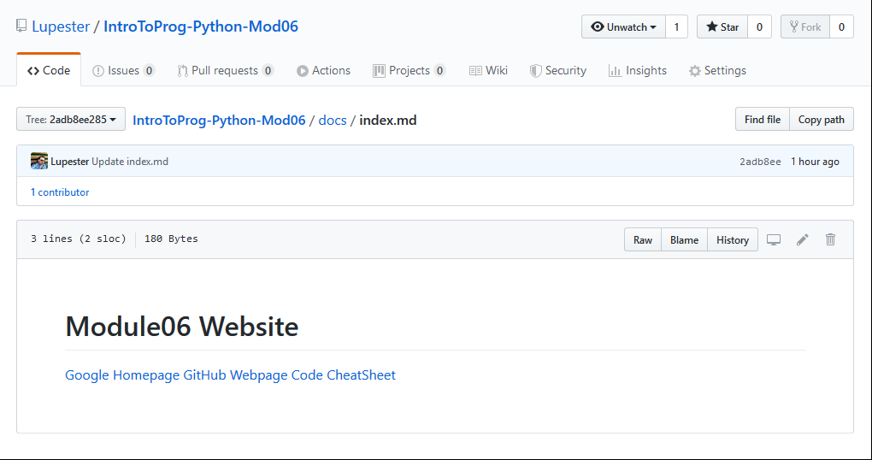

***Figure 1: GitHub Website***

# Creating the Program Script

The objective of the assignment was to import pickle and insert an error handling script. See figure 2.

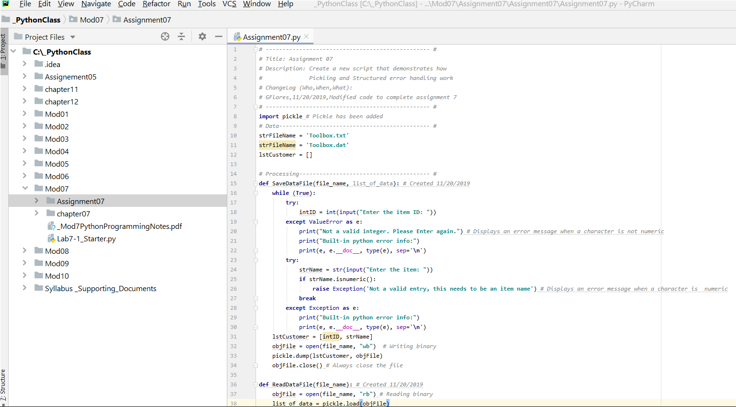

***Figure 2: Entering header information and codes in PyCharm for Module7***

# Running the Script

To test out your script in PyCharm select Run from the task menu. A lower console should open, with a Menu of Options. The user has three options. If the user selects “1) Add and Save Data to file.” The program will request the user enter information. If the user enters a character other, then a numeric, an error message will appear. See Figure 5 and 6. The “Toolbox.dat” file is saved to Windows C: Drive. See figure 7.

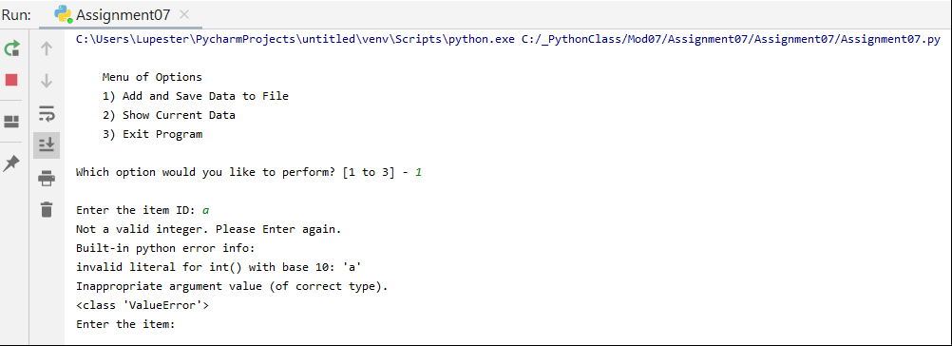

***Figure 5: PyCharm results of running the script shown in the bottom console***

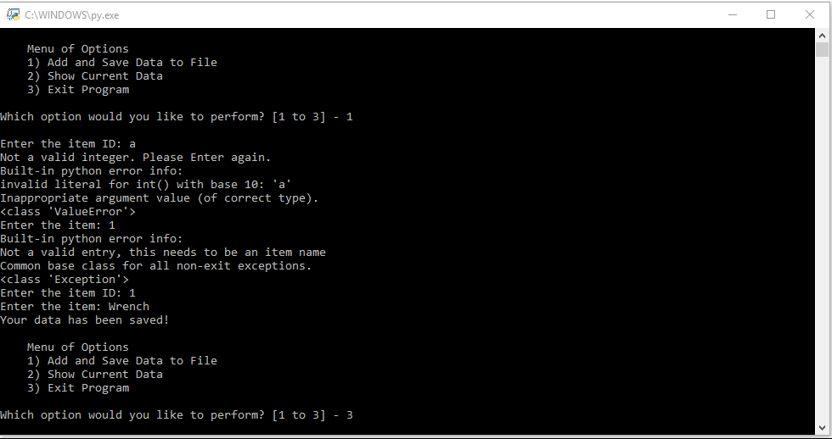

***Figure 6: Command Prompt To-do list Text file list.***

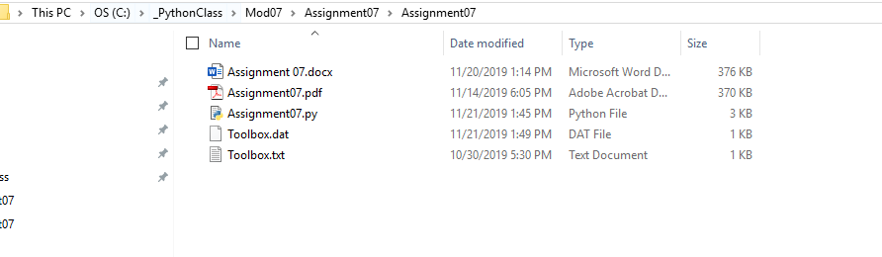

***Figure 7: Toolbox.dat file saved.***

# Summary

In reading Chapter 7, and reviewing the lecture notes, webpages, practices running the lab assignment and reviewing the tutorials. Replicating the steps from assignment 4, I was able to create a subfolder, and a PyCharm file, and essentially adding an error handaling and import, load and dump the pickle.